

Compensation and Pension Record Interchange (CAPRI)

Male Reproductive System Conditions

Disability Benefits Questionnaire (DBQ)

Workflow

April 2011

Department of Veterans Affairs
Office of Enterprise Development
Management & Financial Systems
Revision History

Date | Description (Patch # if applicable) | Author | Technical Writer
2/1/2011 | Document created | M. Guthrie | N/A
4/1/2011 | Changes for patch 163 | M. Guthrie | N/A
4/7/11 | Changed mandatory logic to “Please describe the appliance used for the voiding dysfunction.”  Changed If yes, describe: to If yes, describe the appliance | K. DeLaCruz | N/A

Table of Contents

1 Introduction 1
1.1 Purpose 1
1.2 Overview 1
2 Male Reproductive System Conditions DBQ 2
2.1 Name of patient/Veteran 2
2.2 Section 1. Diagnosis 3
2.3 Section 2. Medical history 14
2.4 Section 3. Voiding dysfunction 17
2.5 Section 4. Urinary tract/kidney infection 23
2.6 Section 5. Erectile dysfunction 27
2.7 Section 6. Retrograde ejaculation 29
2.8 Section 7. Male reproductive organ infections 31
2.9 Section 8. Physical exam 34
2.10 Section 9. Tumors and Neoplasms 39
2.11 Section 10. Other pertinent physical findings, complications, conditions, signs and/or symptoms 44
2.12 Section 11. Diagnostic testing 46
2.13 Section 12. Functional impact 48
2.14 Section 13. Remarks, if any 50
3 Male Reproductive System Conditions DBQ-AMIE Worksheet 51

Table of Figures and Tables

Figure 1: Template Example: DBQ - Standard VA Note 1
Figure 2: Print Example: DBQ – Standard VA Note 1
Figure 3: Template Example: DBQ – Male Reproductive System Conditions – Name of patient/Veteran 2
Figure 4: Print Example: DBQ – Male Reproductive System Conditions – Name of patient/Veteran 2
Figure 5: Template Example: DBQ – Male Reproductive System Conditions – 1. Diagnosis 13
Figure 6: Print Example: DBQ – Male Reproductive System Conditions – 1. Diagnosis 13
Figure 7: Template Example: DBQ – Male Reproductive System Conditions – 2. Medical history 17
Figure 8: Print Example: DBQ – Male Reproductive System Conditions– 2. Medical history 17
Figure 9: Template Example: DBQ – Male Reproductive System Conditions – 3. Voiding dysfunction 21
Figure 10: Print Example: DBQ – Male Reproductive System Conditions – 3. Voiding dysfunction 22
Figure 11: Template Example: DBQ – Male Reproductive System Conditions – 4. Urinary tract/kidney infection 26
Figure 12: Print Example: DBQ – Male Reproductive System Conditions – 4. Urinary tract/kidney infection 26
Figure 13: Template Example: DBQ – Male Reproductive System Conditions –5. Erectile dysfunction 29
Figure 14: Print Example: DBQ – Male Reproductive System Conditions – 5. Erectile dysfunction 29
Figure 15: Template Example: DBQ – Male Reproductive System Conditions –6. Retrograde ejaculation 30
Figure 16: Print Example: DBQ – Male Reproductive System Conditions – 6. Retrograde ejaculation 30
Figure 17: Template Example: DBQ – Male Reproductive System Conditions –7. Male reproductive organ infections 33
Figure 18: Print Example: DBQ – Male Reproductive System Conditions – 7. Male reproductive organ infections 33
Figure 19: Template Example: DBQ – Male Reproductive System Conditions –8. Physical exam 37
Figure 20: Print Example: DBQ – Male Reproductive System Conditions – 8. Physical exam 38
Figure 21: Template Example: DBQ – Male Reproductive System Conditions – 9. Tumors and Neoplasms 43
Figure 22: Print Example: DBQ – Male Reproductive System Conditions – 9. Tumors and Neoplasms 43
Figure 23: Template Example: DBQ – Male Reproductive System Conditions – 10. Other pertinent physical findings, complications, conditions, signs and/or symptoms 46
Figure 24: Print Example: DBQ – Male Reproductive System Conditions – 10. Other pertinent physical findings, complications, conditions, signs and/or symptoms 46
Figure 25: Template Example: DBQ – Male Reproductive System Conditions – 11. Diagnostic testing 48
Figure 26: Print Example: DBQ – Male Reproductive System Conditions– 11. Diagnostic testing 48
Figure 27: Template Example: DBQ – Male Reproductive System Conditions – 12. Functional impact 49
Figure 28: Print Example: DBQ – Male Reproductive System Conditions – 12. Functional impact 49
Figure 29: Template Example: DBQ – Male Reproductive System Conditions – 13. Remarks, if any 50
Figure 30: Print Example: DBQ – Male Reproductive System Conditions – 13. Remarks, if any 50

Table 1: Rules: DBQ – Male Reproductive System Conditions – Name of patient/Veteran 2
Table 2: Rules: DBQ – Male Reproductive System Conditions – 1. Diagnosis 3
Table 3: Rules: DBQ – Male Reproductive System Conditions – 2. Medical history 15
Table 4: Rules: DBQ – Male Reproductive System Conditions – 3. Voiding dysfunction 18
Table 5: Rules: DBQ – Male Reproductive System Conditions – 4.Urinary tract/kidney infection 24
Table 6: Rules: DBQ – Male Reproductive System Conditions – 5. Erectile Dysfunction 28
Table 7: Rules: DBQ – Male Reproductive System Conditions – 6. Retrograde ejaculation 30
Table 8: Rules: DBQ – Male Reproductive System Conditions – 7. Male reproductive organ infections 32
Table 9: Rules: DBQ – Male Reproductive System Conditions – 8. Physical exam 35
Table 10: Rules: DBQ – Male Reproductive System Conditions – 9. Tumors and Neoplasms 40
Table 11: Rules: DBQ – Male Reproductive System Conditions – 10. Other pertinent physical findings, complications, conditions, signs and/or symptoms 45
Table 12: Rules: DBQ – Male Reproductive System Conditions – 11. Diagnostic testing 47
Table 13: Rules: DBQ – Male Reproductive System Conditions – 12. Functional impact 49
Table 14: Rules: DBQ – Male Reproductive System Conditions –13. Remarks, if any 50

Introduction

Purpose
This document provides a high level overview of the contents found on the Male Reproductive System Conditions Disability Benefits Questionnaire (DBQ). The DBQ can be populated via an online template within the CAPRI C&P Worksheets tab and then printed OR it can be printed via AMIE (AUTOMATED MEDICAL INFORMATION EXCHANGE) and then manually populated. This document contains the edit rules for the template as well as an example of how the template will look online in CAPRI or printed from CAPRI. It also contains the layout for the AMIE worksheet to depict how it will look when printed from AMIE.

For more detailed information on standard template functionality not covered in this document, please refer to the C&P Worksheet Tab Functionalities section of the CAPRI GUI User Guide.

Overview
The Male Reproductive System Conditions DBQ provides the ability to capture information related to Male Reproductive Organs and its treatment.

Each DBQ template contains a standard footer containing a note stating that “VA may request additional medical information, including additional examinations if necessary to complete VA’s review of the Veteran’s application.” (see Figure 1 and 2).

Figure 1: Template Example: DBQ - Standard VA Note
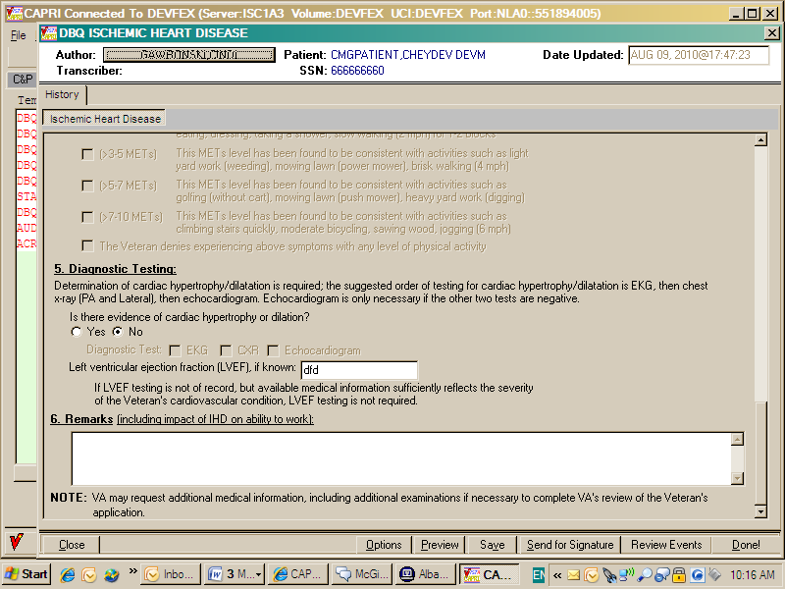

Figure 2: Print Example: DBQ – Standard VA Note

NOTE: VA may request additional medical information, including additional

examinations if necessary to complete VA's review of the Veteran's application.

A number of fields on the Male Reproductive System Conditions DBQ are mandatory and require a response (value) prior to the exam being marked as completed. Some questions may activate a Pop-up window displaying information as to each question that needs to be answered before the template can be completed.

Male Reproductive System Conditions DBQ

Name of patient/Veteran
All questions in this section may be answered as described by the rules below. If mandatory questions are not answered, the error message(s) will appear in a popup window as depicted below.

Table 1: Rules: DBQ – Male Reproductive System Conditions – Name of patient/Veteran
Field/Question | Field Disposition | Valid Values | Format | Error Message
Male Reproductive System Conditions | Enabled, Read-Only | N/A | N/A | N/A
Disability Benefits Questionnaire | Enabled, Read-Only | N/A | N/A | N/A
Name of patient/Veteran: | Enabled, Mandatory | N/A | Free Text | Please enter the name of the patient/Veteran.
Your patient is applying to the U. S. Department of Veterans Affairs (VA) for disability benefits. VA will consider the information you provide on this questionnaire as part of their evaluation in processing the Veteran’s claim. | Enabled, Read-Only | N/A | N/A | N/A

Figure 3: Template Example: DBQ – Male Reproductive System Conditions – Name of patient/Veteran
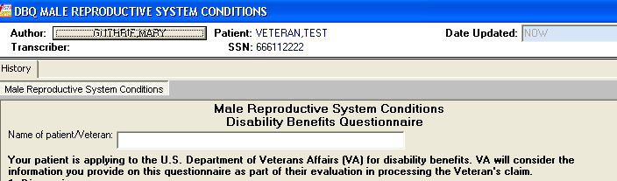

Figure 4: Print Example: DBQ – Male Reproductive System Conditions – Name of patient/Veteran
Male Reproductive System Conditions
Disability Benefits Questionnaire
Name of patient/Veteran:
Your patient is applying to the U.S. Department of Veterans Affairs (VA)
for disability benefits. VA will consider the information you provide on this
questionnaire as part of their evaluation in processing the Veteran's claim.

Section 1. Diagnosis
The question “Does the Veteran now have or has he ever been diagnosed with any conditions of the male reproductive system?” must be answered before the template can be completed.
- If it is answered with Yes, all other questions requiring an answer as described by the rules in this document must be answered before the template can be completed.
- If it is answered with No, the rationale must be completed. The remainder of the template may be completed without answering any additional questions or the user may input answers to any of the optional questions as indicated by the rules described in this document.

All questions will be printed even if they have not been answered.

If all mandatory questions are not answered, the error message(s) will appear in a popup window as depicted below and must be answered before this template can be completed.

Table 2: Rules: DBQ – Male Reproductive System Conditions – 1. Diagnosis
Field/Question | Field Disposition | Valid Values | Format | Error Message
1.Diagnosis | Enabled, Read-Only | N/A | N/A | N/A
Does the Veteran now have or has he ever been diagnosed with any conditions of the male reproductive system? | Enabled, Mandatory; Choose one valid value | [Yes; No] | N/A | Please answer the question: Does the Veteran now have or has he ever been diagnosed with any conditions of the male reproductive system?
If no, provide rationale (e.g., Veteran has never had any known male reproductive organ conditions): | If Does the Veteran now have or has he ever been diagnosed with any conditions of the male reproductive system? = No; Enabled, Mandatory  Else; Disabled | N/A | Free Text | Please provide the rationale for indicating the Veteran has not been diagnosed with a condition of the male reproductive system.
If yes, indicate diagnoses (check all that apply): | If Does the Veteran now have or has he ever been diagnosed with any conditions of the male reproductive system? = Yes; Enabled, Mandatory; Choose one or more valid values  Else; Enabled, Optional | [Erectile dysfunction; Penis, deformity (e.g., Peyronie’s); Testis, atrophy, one or both; Testis, removal, one or both; Epididymitis, chronic; Epididymo-orchitis, chronic; Prostate injury; prostate hypertrophy (BPH); Prostatitis, chronic; Prostate surgical residuals (as addressed in items 3-6); Neoplasms of the male reproductive system; Other male reproductive system condition (specify diagnosis, providing only diagnoses that pertain to male reproductive system)] | N/A | Please indicate the Veteran’s male reproductive system diagnosis.
ICD Code: | If Diagnosis = Yes and if Diagnosis includes Erectile dysfunction; Enabled, Mandatory  If Diagnosis = No and if Diagnosis includes Erectile dysfunction; Enabled, Optional  Else; Disabled | N/A | Free Text | Please enter the ICD code for Erectile dysfunction.
Date of Diagnosis: | If Diagnosis = Yes and if Diagnosis includes Erectile dysfunction; Enabled, Mandatory  If Diagnosis = No and if Diagnosis includes Erectile dysfunction; Enabled, Optional  Else; Disabled | N/A | Free Text | Please enter the date of diagnosis for Erectile dysfunction.
ICD Code: | If Diagnosis = Yes and if Diagnosis includes Penis, deformity (e.g. Peyronie’s); Enabled, Mandatory  If Diagnosis = No and if Diagnosis includes Penis, deformity (e.g. Peyronie’s).; Enabled, Optional  Else; Disabled | N/A | Free Text | Please enter the ICD code for Penis, deformity (e.g. Peyronie’s).
Date of Diagnosis: | If Diagnosis = Yes and if Diagnosis includes Penis, deformity (e.g. Peyronie’s); Enabled, Mandatory  If Diagnosis = No and if Diagnosis includes Penis, deformity (e.g. Peyronie’s).; Enabled, Optional  Else; Disabled | N/A | Free Text | Please enter the date of diagnosis for Penis, deformity (e.g. Peyronie’s).
ICD Code: | If Diagnosis = Yes and if Diagnosis includes Testis, atrophy, one or both; Enabled, Mandatory  If Diagnosis = No and if Diagnosis includes Testis, atrophy, one or both; Enabled, Optional  Else; Disabled | N/A | Free Text | Please enter the ICD code for Testis, atrophy, one or both.
Date of Diagnosis: | If Diagnosis = Yes and if Diagnosis includes Testis, atrophy, one or both; Enabled, Mandatory  If Diagnosis = No and if Diagnosis includes Testis, atrophy, one or both; Enabled, Optional  Else; Disabled | N/A | Free Text | Please enter the date of diagnosis for Testis, atrophy, one or both.
ICD Code: | If Diagnosis = Yes and if Diagnosis includes Testis, removal, one or both; Enabled, Mandatory  If Diagnosis = No and if Diagnosis includes Testis, removal, one or both; Enabled, Optional  Else; Disabled | N/A | Free Text | Please enter the ICD code for Testis, removal, one or both.
Date of Diagnosis: | If Diagnosis = Yes and if Diagnosis includes Testis, removal, one or both; Enabled, Mandatory  If Diagnosis = No and if Diagnosis includes Testis, removal, one or both; Enabled, Optional  Else; Disabled | N/A | Free Text | Please enter the date of diagnosis for Testis, removal, one or both.
ICD Code: | If Diagnosis = Yes and if Diagnosis includes Epididymitis, chronic; Enabled, Mandatory  If Diagnosis = No and if Diagnosis includes Epididymitis, chronic; Enabled, Optional  Else; Disabled | N/A | Free Text | Please enter the ICD code for Epididymitis, chronic.
Date of Diagnosis: | If Diagnosis = Yes and if Diagnosis includes Epididymitis, chronic; Enabled, Mandatory  If Diagnosis = No and if Diagnosis includes Epididymitis, chronic; Enabled, Optional  Else; Disabled | N/A | Free Text | Please enter the date of diagnosis for Epididymitis, chronic.
ICD Code: | If Diagnosis = Yes and if Diagnosis includes Epididymo-orchitis, chronic; Enabled, Mandatory  If Diagnosis = No and if Diagnosis includes Epididymo-orchitis, chronic; Enabled, Optional  Else; Disabled | N/A | Free Text | Please enter the ICD code for Epididymo-orchitis, chronic.
Date of Diagnosis: | If Diagnosis = Yes and if Diagnosis includes Epididymo-orchitis, chronic; Enabled, Mandatory  If Diagnosis = No and if Diagnosis includes Epididymo-orchitis, chronic; Enabled, Optional  Else; Disabled | N/A | Free Text | Please enter the date of diagnosis for Epididymo-orchitis, chronic.
ICD Code: | If Diagnosis = Yes and if Diagnosis includes Prostate injury; Enabled, Mandatory  If Diagnosis = No and if Diagnosis includes Prostate injury; Enabled, Optional  Else; Disabled | N/A | Free Text | Please enter the ICD code for Prostate injury.
Date of Diagnosis: | If Diagnosis = Yes and if Diagnosis includes Prostate injury; Enabled, Mandatory  If Diagnosis = No and if Diagnosis includes Prostate injury; Enabled, Optional  Else; Disabled | N/A | Free Text | Please enter the date of diagnosis for Prostate injury.
ICD Code: | If Diagnosis = Yes and if Diagnosis includes Prostate hypertrophy (BPH); Enabled, Mandatory  If Diagnosis = No and if Diagnosis includes Prostate hypertrophy (BPH); Enabled, Optional  Else; Disabled | N/A | Free Text | Please enter the ICD code for Prostate hypertrophy (BPH).
Date of Diagnosis: | If Diagnosis = Yes and if Diagnosis includes Prostate hypertrophy (BPH); Enabled, Mandatory  If Diagnosis = No and if Diagnosis includes Prostate hypertrophy (BPH); Enabled, Optional  Else; Disabled | N/A | Free Text | Please enter the date of diagnosis for Prostate hypertrophy (BPH).
ICD Code: | If Diagnosis = Yes and if Diagnosis includes Prostatitis, chronic; Enabled, Mandatory  If Diagnosis = No and if Diagnosis includes Prostatitis, chronic; Enabled, Optional  Else; Disabled | N/A | Free Text | Please enter the ICD code for Prostatitis, chronic.
Date of Diagnosis: | If Diagnosis = Yes and if Diagnosis includes Prostatitis, chronic; Enabled, Mandatory  If Diagnosis = No and if Diagnosis includes Prostatitis, chronic; Enabled, Optional  Else; Disabled | N/A | Free Text | Please enter the date of diagnosis for Prostatitis, chronic.
ICD Code: | If Diagnosis = Yes and if Diagnosis includes Prostate surgical residuals; Enabled, Mandatory  If Diagnosis = No and if Diagnosis includes Prostate surgical residuals; Enabled, Optional  Else; Disabled | N/A | Free Text | Please enter the ICD code for Prostate surgical residuals (as addressed in items 3-6).
Date of Diagnosis: | If Diagnosis = Yes and if Diagnosis includes Prostate surgical residuals; Enabled, Mandatory  If Diagnosis = No and if Diagnosis includes Prostate surgical residuals; Enabled, Optional  Else; Disabled | N/A | Free Text | Please enter the date of diagnosis for Prostate surgical residuals (as addressed in items 3-6).
ICD Code: | If Diagnosis = Yes and if Diagnosis includes Neoplasms of the male reproductive system; Enabled, Mandatory  If Diagnosis = No and if Diagnosis includes Neoplasms of the male reproductive system; Enabled, Optional  Else; Disabled | N/A | Free Text | Please enter the ICD code for Neoplasms of the male reproductive system.
Date of Diagnosis: | If Diagnosis = Yes and if Diagnosis includes Neoplasms of the male reproductive system; Enabled, Mandatory  If Diagnosis = No and if Diagnosis includes Neoplasms of the male reproductive system; Enabled, Optional  Else; Disabled | N/A | Free Text | Please enter the date of Neoplasms of the male reproductive system.
ICD Code: | If Diagnosis = Yes and if Diagnosis includes Other male reproductive system condition (specify diagnosis, providing only diagnoses that pertain to male reproductive system.); Enabled, Mandatory  If Diagnosis = No and if Diagnosis includes Other male reproductive system condition (specify diagnosis, providing only diagnoses that pertain to male reproductive system.); Enabled, Optional  Else; Disabled | N/A | Free Text | Please enter the ICD code for Other male reproductive system condition (specify diagnosis, providing only diagnoses that pertain to male reproductive system.
Date of Diagnosis: | If Diagnosis = Yes and if Diagnosis includes Other male reproductive system condition (specify diagnosis, providing only diagnoses that pertain to male reproductive system.); Enabled, Mandatory  If Diagnosis = No and if Diagnosis includes Other male reproductive system condition (specify diagnosis, providing only diagnoses that pertain to male reproductive system.); Enabled, Optional  Else; Disabled | N/A | Free Text | Please enter the date of Other male reproductive system condition (specify diagnosis, providing only diagnoses that pertain to male reproductive system.
Other diagnosis #1: | Enabled, Optional | N/A | Free Text | N/A
ICD code: | If Diagnosis = Yes and Other diagnosis #1 is populated; Enabled, Mandatory  Else; Enabled, Optional | N/A | Free Text | Please enter the ICD code for other diagnosis #1.
Date of diagnosis: | If Diagnosis = Yes and Other diagnosis #1 is populated; Enabled, Mandatory  Else; Enabled, Optional | N/A | Free Text | Please enter the date of other diagnosis #1.
Other diagnosis #2: | Enabled, Optional | N/A | Free Text | N/A
ICD code: | If Diagnosis = Yes and Other diagnosis #2 is populated; Enabled, Mandatory  Else; Enabled, Optional | N/A | Free Text | Please enter the ICD code for other diagnosis #2.
Date of diagnosis: | If Diagnosis = Yes and Other diagnosis #2 is populated; Enabled, Mandatory  Else; Enabled, Optional | N/A | Free Text | Please enter the date of other diagnosis #2.
If there are additional diagnoses that pertain to the male reproductive organ conditions, list using above format: | Enabled, Optional | N/A | Free Text | N/A

Figure 5: Template Example: DBQ – Male Reproductive System Conditions – 1. Diagnosis
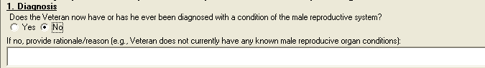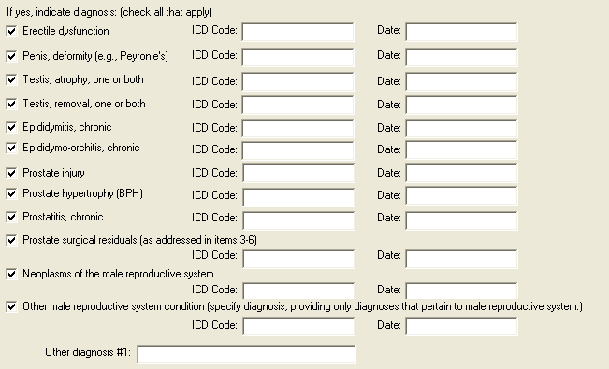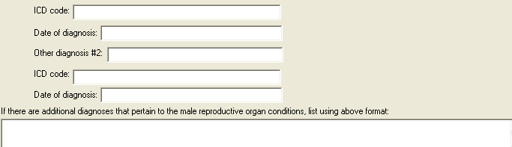

Figure 6: Print Example: DBQ – Male Reproductive System Conditions – 1. Diagnosis
1. Diagnosis
------------
Does the Veteran now have or has he ever been diagnosed with any conditions
of the male reproductive system? [X] Yes [ ] No
If no, provide rationale (e.g., Veteran has never had any known male
reproductive organ conditions):
If yes, indicate diagnoses: (check all that apply)
[ ] Erectile dysfunction
ICD Code: Date of Diagnosis:
[ ] Penis, deformity (e.g., Peyronie's)
ICD Code: Date of Diagnosis:
[ ] Testis, atrophy, one or both
ICD Code: Date of Diagnosis:
[ ] Testis, removal, one or both
ICD Code: Date of Diagnosis:
[ ] Epididymitis, chronic
ICD Code: Date of Diagnosis:
[ ] Epididymo-orchitis, chronic
ICD Code: Date of Diagnosis:
[ ] Prostate injury
ICD Code: Date of Diagnosis:
[ ] Prostate hypertrophy (BPH)
ICD Code: Date of Diagnosis:
[ ] Prostatitis, chronic
ICD Code: Date of Diagnosis:
[ ] Prostate surgical residuals (as addressed in items 3-6)
ICD Code: Date of Diagnosis:
[ ] Neoplasms of the male reproductive system
ICD Code: Date of Diagnosis:
[ ] Other male reproductive system condition (specify diagnosis,
providing only diagnoses that pertain to male reproductive system.)
ICD Code: Date of Diagnosis:
Other diagnosis #1:
ICD code:
Date of diagnosis:
Other diagnosis #2:
ICD code:
Date of diagnosis:
If there are additional diagnoses that pertain to the male reproductive
organ conditions, list using above format:

Section 2. Medical history
All questions in this section may be answered as described by the rules below. If all mandatory questions are not answered, the error message(s) will appear in a popup window as depicted below.

Table 3: Rules: DBQ – Male Reproductive System Conditions – 2. Medical history
Field/Question | Field Disposition | Valid Values | Format | Error Message
2.Medical history | Enabled; Read Only | N/A | N/A | N/A
a. Describe the history (including onset and course) of the Veteran’s male reproductive organ condition(s) (brief summary): | If Diagnosis = Yes and at least one diagnosis selected in the Diagnosis section; Enabled, Mandatory  Else; Enabled, Optional | N/A | Free Text | Please describe the history (including onset and course) of the Veteran’s current male reproductive organ condition(s).
b. Does the Veteran’s treatment plan include taking continuous medication for the diagnosed condition? | If Diagnosis = Yes and at least one diagnosis selected in the Diagnosis section; Enabled, Mandatory  Else; Enabled, Optional  Choose one valid value. | [Yes; No] | N/A | Please provide an answer to the question: Does the Veteran’s treatment plan include taking continuous medication for the diagnosed condition?
List Medications: | If Diagnosis = Yes and Does the Veteran’s treatment plan include taking continuous medication for the diagnosed condition? = Yes; Enabled, Mandatory  If Diagnosis = No and Does the Veteran’s treatment plan include taking continuous medication for the diagnosed condition? = Yes; Enabled, Optional  Else; Disabled | N/A | Free Text | Please list continuous medications taken for the diagnosed condition.
c. Has the Veteran had an orchiectomy? | If Diagnosis = Yes and at least one diagnosis selected in the Diagnosis section; Enabled, Mandatory  Else; Enabled, Optional  Choose one valid value | [Yes; No] | N/A | Please provide an answer to the question: Has the Veteran had an orchiectomy?
Indicate testicle removed: | If Diagnosis = Yes and at least one diagnosis selected in the Diagnosis section and Has the Veteran had an orchiectomy? = Yes; Enabled, Mandatory  If Diagnosis = No and Has the Veteran had an orchiectomy? = Yes; Enabled, Optional  Choose one valid value  Else; Disabled | [Right; Left; Both] | N/A | Please indicate which testicle was removed.
Indicate reason for removal: | If Diagnosis = Yes and at least one diagnosis selected in the Diagnosis section and Has the Veteran had an orchiectomy? = Yes; Enabled, Mandatory  If Diagnosis = No and Has the Veteran had an orchiectomy? = Yes; Enabled, Optional  Choose one valid value  Else; Disabled | [Undescended; Congenitally underdeveloped; Other: provide reason for removal:] | N/A | Please indicate the reason for the orchiectomy.
Other: provide reason for removal: | If Diagnosis = Yes and at least one diagnosis selected in the Diagnosis section and Reason for removal = Other; Enabled, Mandatory  If Diagnosis = No and Has the Veteran had an orchiectomy? = Yes; Enabled, Optional  Else; Disabled | N/A | Free Text | Please provide the other reason for the orchiectomy.

Figure 7: Template Example: DBQ – Male Reproductive System Conditions – 2. Medical history
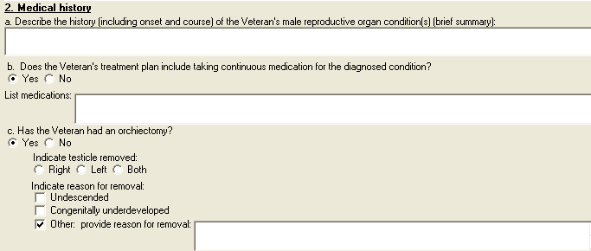

Figure 8: Print Example: DBQ – Male Reproductive System Conditions– 2. Medical history
2. Medical history
------------------
a. Describe the history (including onset and course) of the Veteran's male
reproductive organ condition(s) (brief summary):
b. Does the Veteran's treatment plan include taking continuous medication
for the diagnosed condition?
[X] Yes [ ] No
List medications:
c. Has the Veteran had an orchiectomy?
[X] Yes [ ] No
Indicate testicle removed:
[ ] Right [ ] Left [ ] Both
Indicate reason for removal:
[ ] Undescended
[ ] Congenitally underdeveloped
[X] Other: provide reason for removal:

Section 3. Voiding dysfunction
All questions in this section may be answered as described by the rules below. If all mandatory questions are not answered, the error message(s) will appear in a popup window as depicted below.
Table 4: Rules: DBQ – Male Reproductive System Conditions – 3. Voiding dysfunction
Field/Question | Field Disposition | Valid Values | Format | Error Message
3.Voiding dysfunction | Enabled; Read Only | N/A | N/A | N/A
Does the Veteran have a voiding dysfunction? | If Diagnosis = Yes and at least one diagnosis selected in the Diagnosis section; Enabled; Mandatory.  Else; Optional  Choose one valid value | [Yes; No] | N/A | Please answer the question: Does the Veteran have a voiding dysfunction?
If yes, provide etiology of voiding dysfunction: | Does the Veteran have a voiding dysfunction? = Yes; Enabled; Mandatory  Else; Disabled | N/A | Free Text | Please provide the etiology of the voiding dysfunction.
If the Veteran has a voiding dysfunction, complete the following questions: | If Does the Veteran have a voiding dysfunction? = Yes; Enabled; Read-Only  Else; Disabled | N/A | N/A | N/A
a. Does the voiding dysfunction cause urine leakage? | If Does the Veteran have a voiding dysfunction? = Yes; Enabled; Mandatory; Choose one valid value.  Else; Disabled | [Yes; No] | N/A | Please provide an answer to the question: Does the voiding dysfunction cause urine leakage?
Indicate severity (check one): | If Does the voiding dysfunction cause urine leakage? = Yes;  Enabled; Mandatory; Choose one valid value.  Else; Disabled | [Does not require/does not use absorbent material; Requires absorbent material that is changed less than 2 times per day; Requires absorbent material that is changed 2 to 4 times per day; Requires absorbent material that is changed more than 4 times per day; Other, describe:] | N/A | Please check the applicable statement pertaining to the voiding dysfunction causing urine leakage.
Other, describe: | If Severity = Other, Enabled, Mandatory  Else; Disabled | N/A | Free Text | Please describe the other voiding dysfunction which causes urine leakage.
b. Does the voiding dysfunction require the use of an appliance? | If Does the Veteran have a voiding dysfunction? = Yes; Enabled; Mandatory; Choose one valid value.  Else; Disabled | [Yes; No] | N/A | Please provide an answer to the question: Does the voiding dysfunction require the use of an appliance?
If yes, describe the appliance: | If Does the voiding dysfunction require the use of an appliance? = Yes; Enabled, Mandatory  Else; Disabled | N/A | Free Text | Please describe the appliance used for the voiding dysfunction.
c. Does the voiding dysfunction cause increased urinary frequency? | If Does the Veteran have a voiding dysfunction? = Yes; Enabled; Mandatory; Choose one valid value.  Else; Disabled | [Yes; No] | N/A | Please provide an answer to the question: Does the voiding dysfunction cause increased urinary frequency?
If yes, check all that apply: | If Does the voiding dysfunction cause increased urinary frequency?= Yes;  Enabled; Mandatory; Choose one valid value for Daytime and one valid value for Nighttime.  Else; Disabled | [Daytime voiding interval between 2 and 3 hours; Daytime voiding interval between 1 and 2 hours; Daytime voiding interval less than 1 hour]  [Nighttime awakening to void 2 times; Nighttime awakening to void 3 to 4 times; Nighttime awakening to void 5 or more times] | N/A | Please check the applicable statement(s) pertaining to the voiding dysfunction causing signs and/or symptoms of urinary frequency.
d. Does the voiding dysfunction cause signs or symptoms of obstructed voiding? | If Does the Veteran have a voiding dysfunction? = Yes; Enabled; Mandatory; Choose one valid value.  Else; Disabled | [Yes; No] | N/A | Please provide an answer to the question: Does the voiding dysfunction cause signs or symptoms of obstructed voiding?
If yes, check all that apply: | If Does the voiding dysfunction cause signs or symptoms of obstructed voiding? = Yes; Enabled; Mandatory; Choose one or more valid values.  Else; Disabled | [Hesitancy; slow or weak stream; decreased force of stream; stricture disease requiring dilatation 1 to 2 times per year; stricture disease requiring periodic dilatation every 2 to 3 months; recurrent urinary tract infections secondary to obstruction; uroflowmetry peak flow rate less than 10 cc/sec; post void residuals greater than 150 cc; urinary retention requiring intermittent catheterization; urinary retention requiring continuous catheterization; Other, describe:] | N/A | Please check one or more boxes to indicate the signs and symptoms of obstructed voiding.
If checked, is hesitancy marked? | If Voiding dysfunction signs or symptoms include Hesitancy; Enabled, Mandatory; Choose one valid value  Else; Disabled | [Yes; No] | N/A | Please indicate whether or not hesitancy is marked.
If checked, is stream markedly slow or weak? | If Voiding dysfunction signs or symptoms include Slow or weak stream; Enabled, Mandatory; Choose one valid value  Else; Disabled | [Yes; No] | N/A | Please indicate whether or not stream is markedly slow or weak.
If checked, is force of stream markedly decreased? | If Voiding dysfunction signs or symptoms include Decreased force of stream; Enabled, Mandatory; Choose one valid value.  Else; Disabled | [Yes; No] | N/A | Please indicate whether or not force of stream is markedly decreased.
Other, describe: | If Voiding dysfunction signs or symptoms include Other; Enabled; Mandatory  Else Disabled | N/A | Free Text | Please describe the other signs and symptoms of obstructed voiding.

Figure 9: Template Example: DBQ – Male Reproductive System Conditions – 3. Voiding dysfunction
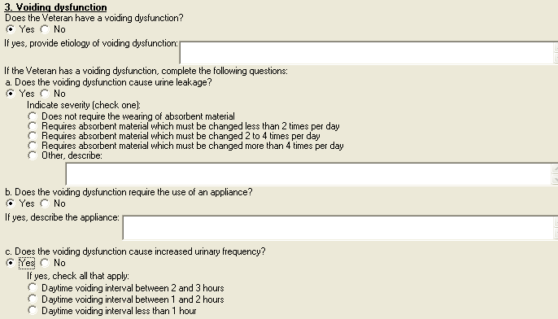
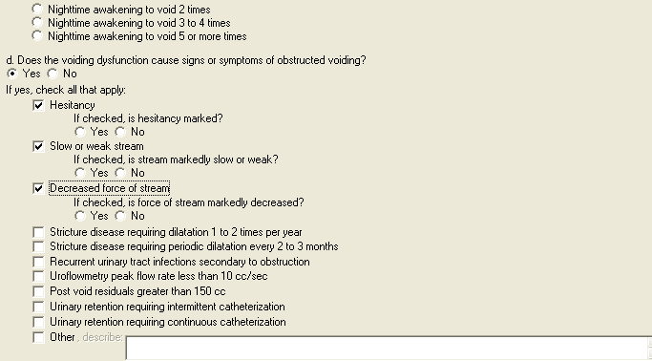

Figure 10: Print Example: DBQ – Male Reproductive System Conditions – 3. Voiding dysfunction
3. Voiding dysfunction
----------------------
Does the Veteran have a voiding dysfunction?
[X] Yes [ ] No
If yes, provide etiology of voiding dysfunction:
If the Veteran has a voiding dysfunction, complete the following questions:
a. Does the voiding dysfunction cause urine leakage?
[X] Yes [ ] No
Indicate severity (check one)
[X] Does not require the wearing of absorbent material
[ ] Requires absorbent material which must be changed less than 2
times per day
[ ] Requires absorbent material which must be changed 2 to 4
times per day
[ ] Requires absorbent material which must be changed more than 4
times per day
[ ] Other, describe:
b. Does the voiding dysfunction require the use of an appliance?
[X] Yes [ ] No
If yes, describe the appliance:
c. Does the voiding dysfunction cause increased urinary frequency?
[ ] Yes [X] No
If yes, check all that apply:
[ ] Daytime voiding interval between 2 and 3 hours
[ ] Daytime voiding interval between 1 and 2 hours
[ ] Daytime voiding interval less than 1 hour
[ ] Nighttime awakening to void 2 times
[ ] Nighttime awakening to void 3 to 4 times
[ ] Nighttime awakening to void 5 or more times
d. Does the voiding dysfunction cause signs or symptoms of obstructed
voiding?
[X] Yes [ ] No
If yes, check all that apply:
[X] Hesitancy
If checked, is hesitancy marked?
[ ] Yes [ ] No
[X] Slow or weak stream
If checked, is stream markedly slow or weak?
[ ] Yes [ ] No
[X] Decreased force of stream
If checked, is force of stream markedly decreased?
[ ] Yes [ ] No
[ ] Stricture disease requiring dilatation 1 to 2 times per year
[ ] Stricture disease requiring periodic dilatation every 2 to 3
months
[ ] Recurrent urinary tract infections secondary to obstruction
[ ] Uroflowmetry peak flow rate less than 10 cc/sec
[ ] Post void residuals greater than 150 cc
[ ] Urinary retention requiring intermittent catheterization
[ ] Urinary retention requiring continuous catheterization
[X] Other, describe:

Section 4. Urinary tract/kidney infection
All questions in this section may be answered as described by the rules below. If all mandatory questions are not answered, the error message(s) will appear in a popup window as depicted below.

Table 5: Rules: DBQ – Male Reproductive System Conditions – 4.Urinary tract/kidney infection
Field/Question | Field Disposition | Valid Values | Format | Error Message
4. Urinary tract/kidney infection | Enabled, Read-Only | N/A | N/A | N/A
Does the Veteran have a history of recurrent symptomatic urinary tract or kidney infections? | If Diagnosis = Yes and at least one diagnosis selected in the Diagnosis section; Enabled, Mandatory, Choose one valid value.  Else, Enabled, Optional | [Yes; No] | N/A | Please answer the question: Does the Veteran have a history of recurrent symptomatic urinary tract or kidney infections?
If Yes, provide etiology: | If Does the Veteran have a history of recurrent symptomatic urinary tract or kidney infections? = Yes; Enabled, Mandatory  Else; Disabled | N/A | Free Text | Please provide the etiology of the recurrent symptomatic urinary tract or kidney infections.
If the Veteran has had recurrent symptomatic urinary tract or kidney infections, indicate all treatment modalities that apply: | If Does the Veteran have a history of recurrent symptomatic urinary tract or kidney infections? = Yes; Enabled, Mandatory, Choose one or more valid values.  Else; Disabled | [No treatment; OR Long-term drug therapy; Hospitalization; Drainage; Continuous intensive management; Intermittent intensive management; Other, describe:] | N/A | Please check one or more boxes to indicate applicable treatment modalities for recurrent symptomatic urinary tract or kidney infections.
If checked, list medications used and indicate dates for courses of treatment over the past 12 months: | If treatment modalities include long-term drug therapy; Enabled; Mandatory  Else; Disabled | N/A | Free Text | Please list medications used for urinary tract or kidney infections and their treatment dates.
If checked, indicate frequency of hospitalization: | If treatment modalities include hospitalization; Enabled, Mandatory, Choose one valid value  Else; Disabled | [1 or 2 per year; >2 per year] | N/A | Please indicate the frequency of hospitalization.
If checked, indicate dates when drainage performed over past 12 months: | If treatment modalities include drainage; Enabled, Mandatory  Else; Disabled | N/A | Free Text | Please indicate the dates that drainage was performed over the past 12 months.
If checked, indicate types of treatment and medications used over past 12 months: | If treatment modalities include continuous intensive management; Enabled, Mandatory  Else; Disabled | N/A | Free Text | Please describe the types of treatment and medications for continuous intensive management used over the past 12 months.
If checked, indicate types of treatment and medications used over past 12 months: | If treatment modalities include intermittent intensive management; Enabled, Mandatory  Else; Disabled | N/A | Free Text | Please describe the types of treatment and medications for intermittent intensive management used over the past 12 months.
Other, describe: | If treatment modalities include other; Enabled, Mandatory  Else; Disabled | N/A | Free Text | Please describe other treatment modalities used for urinary tract or kidney infections.

Figure 11: Template Example: DBQ – Male Reproductive System Conditions – 4. Urinary tract/kidney infection
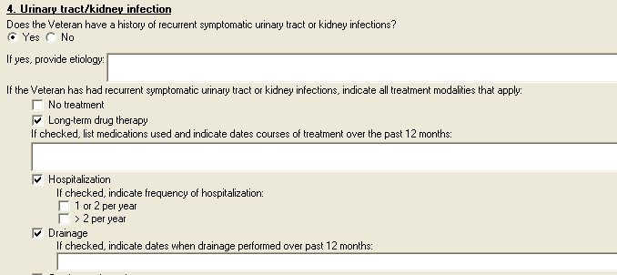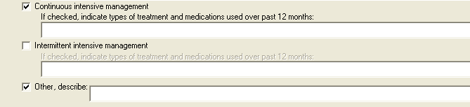

Figure 12: Print Example: DBQ – Male Reproductive System Conditions – 4. Urinary tract/kidney infection
4. Urinary tract/kidney infection
---------------------------------
Does the Veteran have a history of recurrent symptomatic urinary tract or
kidney infections?
[ ] Yes [X] No
If yes, provide etiology:
If the Veteran has had recurrent symptomatic urinary tract or kidney
infections, indicate all treatment modalities that apply:
[ ] No treatment
[ ] Long-term drug therapy
If checked, list medications used and indicate dates for
courses of treatment over the past 12 months:
[ ] Hospitalization
If checked, indicate frequency of hospitalization:
[ ] 1 or 2 per year
[ ] > 2 per year
[ ] Drainage
If checked, indicate dates when drainage performed over past
12 months:
[ ] Continuous intensive management
If checked, indicate types of treatment and medications used
over past 12 months:
[ ] Intermittent intensive management
If checked, indicate types of treatment and medications used
over past 12 months:
[ ] Other, describe:

Section 5. Erectile dysfunction
All questions in this section may be answered as described by the rules below. If all mandatory questions are not answered, the error message(s) will appear in a popup window as depicted below.

Table 6: Rules: DBQ – Male Reproductive System Conditions – 5. Erectile Dysfunction
Field/Question | Field Disposition | Valid Values | Format | Error Message
5. Erectile dysfunction | Enabled; Read-Only | N/A | N/A | N/A
a. Does the Veteran have erectile dysfunction? | If Diagnosis = Yes and at least one diagnosis selected in the Diagnosis section; Enabled, Mandatory  Else, Enabled, Optional  Choose one valid value. | [Yes; No] | N/A | Please provide an answer to the question: Does the Veteran have erectile dysfunction?
If yes, provide etiology: | If Does the Veteran have erectile dysfunction? = Yes; Enabled, Mandatory  Else; Disabled | N/A | Free Text | Please provide the etiology of erectile dysfunction.
b. If the Veteran has erectile dysfunction, is it as likely as not (at least 50% probability) attributable to one of the diagnoses in Section 1, including residuals of treatment for this diagnosis? | If Does the Veteran have erectile dysfunction? = Yes; Enabled, Mandatory, Choose one valid value.  Else; Disabled | [Yes; No] | N/A | Please answer whether or not erectile dysfunction is attributable to one of the diagnoses in Section 1, including its residuals of treatment.
If yes, specify the diagnosis to which the erectile dysfunction is as likely as not attributable: | If previous question = Yes; Enabled, Mandatory  Else; Disabled | N/A | Free Text | Please specify the diagnosis to which erectile dysfunction is as likely as not attributable.
c. If the Veteran has erectile dysfunction, is he able to achieve an erection sufficient for penetration and ejaculation (without medication)? | If Does the Veteran have erectile dysfunction? = Yes; Enabled, Mandatory; Choose one valid value.  Else; Disabled | [Yes; No] | N/A | Please answer whether or not the Veteran is able to achieve an erection sufficient for penetration and ejaculation (without medication).
If no, is the Veteran able to achieve an erection sufficient for penetration and ejaculation (with medication)? | If previous question = No; Enabled, Mandatory; Choose one valid value.  Else; Disabled | [Yes; No] | N/A | Please answer whether or not the Veteran is able to achieve an erection sufficient for penetration and ejaculation (with medication).

Figure 13: Template Example: DBQ – Male Reproductive System Conditions –5. Erectile dysfunction
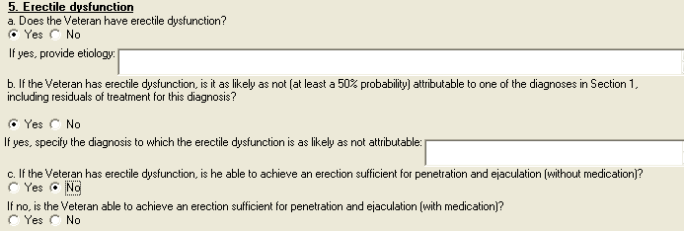

Figure 14: Print Example: DBQ – Male Reproductive System Conditions – 5. Erectile dysfunction
5. Erectile dysfunction
-----------------------
a. Does the Veteran have erectile dysfunction?
[ ] Yes [ ] No
If yes, provide etiology:
b. If the Veteran has erectile dysfunction, is it as likely as not (at
least a 50% probability) attributable to one of the diagnoses in Section 1,
including residuals of treatment for this diagnosis?
[ ] Yes [ ] No
If yes, specify the diagnosis to which the erectile dysfunction is
as likely as not attributable:
c. If the Veteran has erectile dysfunction, is he able to achieve an
erection sufficient for penetration and ejaculation (without medication)?
[ ] Yes [ ] No
If no, is the Veteran able to achieve an erection sufficient for
penetration and ejaculation (with medication)?
[ ] Yes [ ] No

Section 6. Retrograde ejaculation
All questions in this section may be answered as described by the rules below. If all mandatory questions are not answered, the error message(s) will appear in a popup window as depicted below.

Table 7: Rules: DBQ – Male Reproductive System Conditions – 6. Retrograde ejaculation
Field/Question | Field Disposition | Valid Values | Format | Error Message
6. Retrograde ejaculation | Enabled; Read-Only | N/A | N/A | N/A
a. Does the Veteran have retrograde ejaculation? | If Diagnosis = Yes and at least one diagnosis selected in the Diagnosis section; Enabled, Mandatory  Else, Enabled, Optional  Choose one valid value | [Yes; No] | Free Text | Please provide an answer to the question: Doe the Veteran have retrograde ejaculation?
If yes, provide etiology of the retrograde ejaculation: | If Does the Veteran have retrograde ejaculation? = Yes; Enabled, Mandatory  Else; Disabled | N/A | Free Text | Please provide the etiology of retrograde ejaculation.
b. If the Veteran has retrograde ejaculation, is it as likely as not (at least a 50% probability) attributable to one of the diagnoses in Section 1, including residuals of treatment for this diagnosis? | If Does the Veteran have retrograde ejaculation? = Yes; Enabled, Mandatory; Choose one valid value.  Else; Disabled | [Yes; No] | N/A | Please answer whether or not retrograde ejaculation is attributable to one of the diagnoses in Section 1, including its residuals of treatment.
If yes, specify the diagnosis to which the retrograde ejaculation is as likely as not attributable: | If previous question = Yes; Enabled, Mandatory  Else; Disabled | N/A | Free Text | Please specify the diagnosis to which retrograde ejaculation is as likely as not attributable.

Figure 15: Template Example: DBQ – Male Reproductive System Conditions –6. Retrograde ejaculation
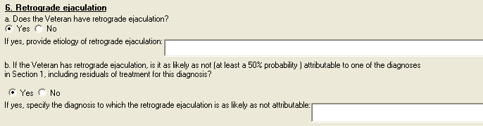

Figure 16: Print Example: DBQ – Male Reproductive System Conditions – 6. Retrograde ejaculation
6. Retrograde ejaculation
-------------------------
a. Does the Veteran have retrograde ejaculation?
[ ] Yes [ ] No
If yes, provide etiology of the retrograde ejaculation:
b. If the Veteran has retrograde ejaculation, is it as likely as not (at
least a 50% probability ) attributable to one of the diagnoses in Section 1,
including residuals of treatment for this diagnosis?
[ ] Yes [ ] No
If yes, specify the diagnosis to which the retrograde ejaculation is
as likely as not attributable:

Section 7. Male reproductive organ infections
All questions in this section may be answered as described by the rules below. If all mandatory questions are not answered, the error message(s) will appear in a popup window as depicted below.

Table 8: Rules: DBQ – Male Reproductive System Conditions – 7. Male reproductive organ infections
Field/Question | Field Disposition | Valid Values | Format | Error Message
7. Male reproductive organ infections | Enabled; Read-Only | N/A | N/A | N/A
b. Does the Veteran have a history of chronic epididymitis, epididymo-orchitis or prostatitis? | If Diagnosis = Yes and at least one diagnosis selected in the Diagnosis section; Enabled, Mandatory  Else, Enabled, Optional  Choose one valid value | [Yes; No] | N/A | Please provide an answer to the question: Does the Veteran have a history of chronic epididymitis, epididymo-orchitis or prostatitis?
If yes, indicate all treatment modalities that apply: | If Does the Veteran have a history of chronic epididymitis, epididymo-orchitis or prostatitis? = Yes, Enabled, Mandatory; Choose one or more valid values.  Else disabled | [No treatment; OR Long-term drug therapy; Hospitalization; Continuous intensive management; Intermittent intensive management; Other, describe:] | N/A | Please check one or more boxes to indicate applicable treatment modalities for chronic epididymitis.
If checked, list medications used and indicate dates for courses of treatment over the past 12 months: | If treatment modalities include Long-term drug therapy; Enabled, Mandatory  Else; Disabled | N/A | Free Text | Please list medications used for chronic epididymitis, epididymo-orchitis or prostatitis, and their treatment dates.
If checked, indicate frequency of hospitalization: | If treatment modalities include hospitalization; Enabled, Mandatory; Choose one valid value  Else; Disabled | [1 or 2 per year; > 2 per year] | N/A | Please indicate the frequency of hospitalization.
If checked, indicate types of treatment and medications used over the past 12 months: | If treatment modalities include continuous intensive management; Enabled, Mandatory  Else; Disabled | N/A | Free Text | Please describe the types of treatment and medications for continuous intensive management used over the past 12 months.
If checked, indicate types of treatment and medications used over the past 12 months: | If treatment modalities include intermittent intensive management; Enabled, Mandatory  Else; Disabled | N/A | Free Text | Please describe the types of treatment and medications for intermittent intensive management used over the past 12 months.
Other, describe: | If treatment modalities include other; Enabled, Mandatory  Else; Disabled | N/A | Free Text | Please describe the other treatment modalities used for chronic epididymitis, epididymo-orchitis or prostatitis.

Figure 17: Template Example: DBQ – Male Reproductive System Conditions –7. Male reproductive organ infections
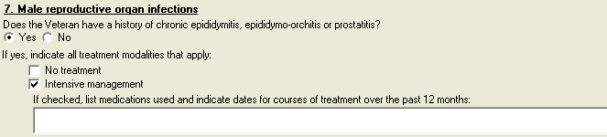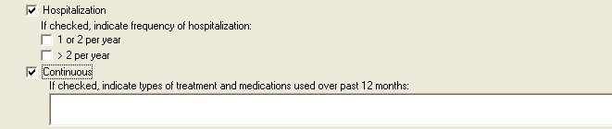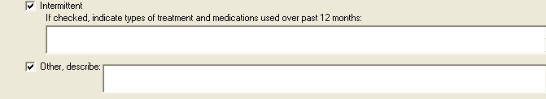

Figure 18: Print Example: DBQ – Male Reproductive System Conditions – 7. Male reproductive organ infections
7. Male reproductive organ infections
-------------------------------------
Does the Veteran have a history of chronic epididymitis, epididymo-orchitis
or prostatitis?
[ ] Yes [ ] No
If yes, indicate all treatment modalities that apply:
[ ] No treatment
[ ] Long-term drug therapy
If checked, list medications used and indicate dates for courses
of treatment over the past 12 months:
[ ] Hospitalization
If checked, indicate frequency of hospitalization:
[ ] 1 or 2 per year
[ ] > 2 per year
[ ] Continuous intensive management
If checked, indicate types of treatment and medications used over
past 12 months:
[ ] Intermittent intensive management
If checked, indicate types of treatment and medications used over
past 12 months:
[ ] Other, describe:

Section 8. Physical exam
All questions in this section may be answered as described by the rules below. If all mandatory questions are not answered, the error message(s) will appear in a popup window as depicted below.

Table 9: Rules: DBQ – Male Reproductive System Conditions – 8. Physical exam
Field/Question | Field Disposition | Valid Values | Format | Error Message
8. Physical exam | Enabled; Read-Only | N/A | N/A | N/A
a. Penis | If Diagnosis = Yes and at least one diagnosis selected in the Diagnosis section; Enabled, Mandatory  Else; Enabled, Optional  Choose one valid value | [Normal; Not examined per Veteran’s request; Not examined, penis exam not relevant to condition; Abnormal] | N/A | Please select a value from the penis exam group.
If abnormal, indicate severity: | If Penis exam =Abnormal, Enabled, Mandatory, Choose one valid value.  Else; Disabled | [Loss/removal of half or more of penis; Loss/removal of glans penis; Penis deformity (such as Peyronie’s disease) | N/A | Please indicate the severity of the penis abnormality.
If checked, describe: | If Penis exam = Penis deformity (such as Peyronie’s disease), Enabled, Mandatory  Else; Disabled | N/A | Free Text | Please describe penis deformity.
b. Testes | If Diagnosis = Yes and at least one diagnosis selected in the Diagnosis section;; Enabled, Mandatory  Else; Enabled, Optional  Choose one valid value. | [Normal; Not examined per Veteran’s request; Not examined, testicular exam not relevant to condition; Abnormal] | N/A | Please select a value from the testes exam group.
If abnormal, check all that apply:  Right testicle: | If Testicular exam = Abnormal AND no abnormality selected for either right or left testicle; Enabled, Mandatory, Choose one or more valid values.  Else; Disabled | [Size 1/3 or less of normal; Size ½ to 1/3 of normal; Considerably harder than normal; Considerably softer than normal; Absent; Other abnormality] | N/A | Please indicate the testes abnormality.
Describe: | If Right testicular exam includes Other abnormality; Enabled, Mandatory  Else; Disabled | N/A | Free Text | Please describe the other abnormality of the right testicle.
Left: | If Testicular exam = Abnormal AND no abnormality selected for either right or left testicle; Enabled, Mandatory, Choose one or more valid values.  Else; Disabled | [Size 1/3 or less of normal; Size ½ to 1/3 of normal; Considerably harder than normal; Considerably softer than normal; Absent; Other abnormality] | N/A | Please indicate the testes abnormality.
Describe: | If Left testicular exam includes Other abnormality; Enabled, Mandatory  Else; Disabled | N/A | Free Text | Please describe the other abnormality of the left testicle.
c. Epididymis | If Diagnosis = Yes and at least one diagnosis selected in the Diagnosis section; Enabled, Mandatory  Else; Enabled, Optional  Choose one valid value. | [Normal; Not examined per Veteran’s request; Not examined, epididymis exam not relevant to condition; Abnormal] | N/A | Please select a value from the epididymis exam group.
If abnormal, check all that apply:  Right epididymis: | If Epididymis exam = Abnormal AND no abnormality selected for either right or left epididymis; Enabled, Mandatory; Choose one valid value.  Else; Disabled | [Tender to palpation; Other, describe] | N/A | Please indicate the epididymis abnormality.
Other, describe: | If Epididymis exam includes other; Enabled, Mandatory  Else; Disabled | N/A | Free Text | Please describe the other abnormality of the right epididymis.
Left epididymis: | If Epididymis exam = Abnormal AND no abnormality selected for either right or left epididymis; Enabled, Mandatory; Choose one valid value  Else; Disabled | [Tender to palpation; Other, describe] | N/A | Please indicate the epididymis abnormality.
Other, describe: | If Epididymis exam includes other; Enabled, Mandatory  Else; Disabled | N/A | Free Text | Please describe the other abnormality of the left epididymis.
d. Prostate | If Diagnosis = Yes and at least one diagnosis selected in the Diagnosis section; Enabled, Mandatory  Else; Enabled, Optional  Choose one valid value | [Normal; Not examined per Veteran’s request; Not examined, prostate exam not relevant to condition; Abnormal] | N/A | Please select a value from the prostate exam group.
If abnormal, describe: | If Prostate exam = abnormal; Enabled, Mandatory  Else; Disabled | N/A | Free Text | Please describe the abnormality of the prostate.

Figure 19: Template Example: DBQ – Male Reproductive System Conditions –8. Physical exam
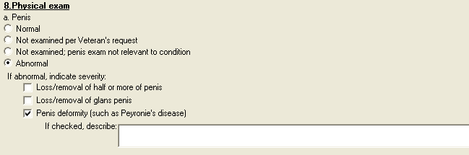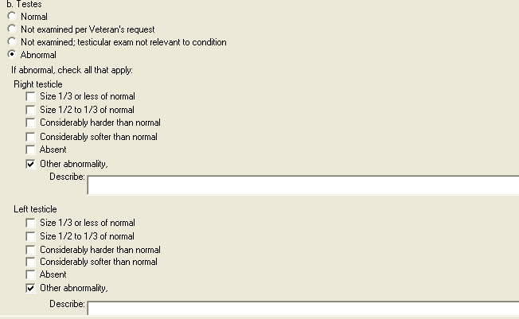
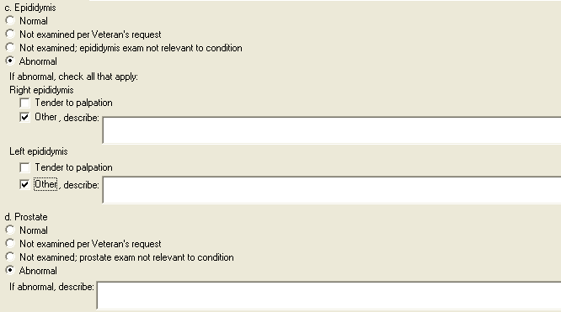

Figure 20: Print Example: DBQ – Male Reproductive System Conditions – 8. Physical exam
8.Physical exam
---------------
a. Penis
[ ] Normal
[ ] Not examined per Veteran's request
[ ] Not examined; penis exam not relevant to condition
[ ] Abnormal
If abnormal, indicate severity:
[ ] Loss/removal of half or more of penis
[ ] Loss/removal of glans penis
[ ] Penis deformity (such as Peyronie's disease)
If checked, describe:
b. Testes
[ ] Normal
[ ] Not examined per Veteran's request
[ ] Not examined; testicular exam not relevant to condition
[ ] Abnormal
If abnormal, check all that apply:
Right testicle
[ ] Size 1/3 or less of normal
[ ] Size 1/2 to 1/3 of normal
[ ] Considerably harder than normal
[ ] Considerably softer than normal
[ ] Absent
[ ] Other abnormality,
Describe:
Left testicle
[ ] Size 1/3 or less of normal
[ ] Size 1/2 to 1/3 of normal
[ ] Considerably harder than normal
[ ] Considerably softer than normal
[ ] Absent
[ ] Other abnormality,
Describe:
c. Epididymis
[ ] Normal
[ ] Not examined per Veteran's request
[ ] Not examined; epididymis exam not relevant to condition
[ ] Abnormal
If abnormal, check all that apply:
Right epididymis
[ ] Tender to palpation
[ ] Other, describe:
Left epididymis
[ ] Tender to palpation
[ ] Other, describe:
d. Prostate
[ ] Normal
[ ] Not examined per Veteran's request
[ ] Not examined; prostate exam not relevant to condition
[ ] Abnormal
If abnormal, describe:

Section 9. Tumors and Neoplasms

All questions in this section may be answered as described by the rules below. If all mandatory questions are not answered, the error message(s) will appear in a popup window as depicted below.

Table 10: Rules: DBQ – Male Reproductive System Conditions – 9. Tumors and Neoplasms
Field/Question | Field Disposition | Valid Values | Format | Error Message
9. Tumors and Neoplasms | Enabled, Read-Only | N/A | N/A | N/A
a. Does the Veteran have a benign or malignant neoplasm or metastases related to any of the diagnoses in the Diagnosis section? | If Diagnosis = Yes and at least one diagnosis selected in the Diagnosis section; Enabled, Mandatory  Else; Enabled, Optional  Choose one valid value. | [Yes; No] | N/A | Please provide an answer to the question: Does the Veteran have a benign or malignant neoplasm or metastases related to any of the diagnoses in the Diagnosis section?
If yes, complete the following: | If Does the Veteran have a benign or malignant neoplasm or metastases related to any of the diagnoses in the Diagnosis section?? = Yes; Enabled, Read-Only  Else; Disabled | N/A | N/A | N/A
b. Is the neoplasm | If Does the Veteran have a benign or malignant neoplasm or metastases related to any of the diagnoses in the Diagnosis section? = Yes; Enabled; Mandatory, Choose one valid value.  Else; Disabled | [Benign; Malignant] | N/A | Please indicate whether the neoplasm is benign or malignant.
c. Has the Veteran completed treatment or is the Veteran currently undergoing treatment for a benign or malignant neoplasm or metastases? | If Does the Veteran have a benign or malignant neoplasm or metastases related to any of the diagnoses in the Diagnosis section? = Yes; Enabled; Mandatory, Choose one valid value.  Else; Disabled | [Yes; No, watchful waiting] | N/A | Please provide an answer to the question: Has the Veteran completed treatment or is the Veteran currently undergoing treatment for a benign or malignant neoplasm or metastases?
If yes, indicate type of treatment the Veteran is currently undergoing or has completed (check all that apply): | If Has the Veteran completed treatment or is the Veteran currently undergoing treatment for a benign or malignant neoplasm or metastases? = Yes; Enabled, Mandatory, Choose one or more valid values.  Else; Disabled | [Treatment completed, currently in watchful waiting status; OR Surgery; Radiation therapy; Antineoplastic chemotherapy; Other therapeutic procedure; Other therapeutic treatment] | N/A | Please indicate all applicable treatment types for a benign or malignant neoplasm or metastases that the Veteran either is currently undergoing or has completed.
If checked, describe: | If treatments include Surgery; Enabled, Mandatory  Else; Disabled | N/A | Free Text | Please describe the surgery.
Date(s) of surgery: | If treatments include Surgery; Enabled, Mandatory  Else; Disabled | N/A | Free Text | Please enter the date(s) of surgery.
Date of most recent treatment: | If treatments include Radiation therapy; Enabled, Mandatory  Else; Disabled | N/A | Free Text | Please enter the date of the most recent radiation therapy treatment.
Date of completion of treatment or anticipated date of completion: | If treatments include Radiation therapy; Enabled, Mandatory  Else; Disabled | N/A | Free Text | Please enter the date (actual or anticipated) of completion of the radiation therapy treatment,
Date of most recent treatment: | If treatments include Antineoplastic chemotherapy; Enabled, Mandatory  Else; Disabled | N/A | Free Text | Please enter the date of the most recent antineoplastic chemotherapy treatment.
Date of completion of treatment or anticipated date of completion: | If treatments include Antineoplastic chemotherapy; Enabled, Mandatory  Else; Disabled | N/A | Free Text | Please enter the date (actual or anticipated) of completion of the antineoplastic chemotherapy treatment.
If checked, describe procedure: | If treatments include Other therapeutic procedure; Enabled, Mandatory  Else; Disabled | N/A | Free Text | Please describe the other therapeutic procedure.
Date of most recent procedure: | If treatments include Other therapeutic procedure; Enabled, Mandatory  Else; Disabled | N/A | Free Text | Please enter the date of the most recent other therapeutic procedure.
If checked, describe treatment: | If treatments include Other therapeutic treatment; Enabled, Mandatory  Else; Disabled | N/A | Free Text | Please describe the other therapeutic treatment.
Date of completion of treatment or anticipated date of completion: | If treatments include Other therapeutic treatment; Enabled, Mandatory  Else; Disabled | N/A | Free Text | Please enter the date (actual or anticipated) of completion of the other therapeutic treatment.
d. Does the Veteran currently have any residual conditions or complications due to the neoplasm (including metastases) or its treatment other than those already documented in the report above? | If Does the Veteran have a benign or malignant neoplasm or metastases related to any of the diagnoses in the Diagnosis section? = Yes; Enabled; Mandatory, Choose one valid value  Else; Disabled | [Yes; No] |  | Please indicate whether or not the Veteran has any residual conditions or complications due to the neoplasm (including metastases) or its treatment, other than those already documented.
If yes, list residual conditions and complications (brief summary): | If previous question = Yes; Enabled, Mandatory  Else; Disabled | N/A | Free Text | Please list the residual conditions and complications due to the neoplasm (including metastases) or its treatment.
e. If there are additional benign or malignant neoplasms or metastases related to any of the diagnoses in the Diagnosis section, describe using the above format: | If Does the Veteran have a benign or malignant neoplasm or metastases related to any of the diagnoses in the Diagnosis section? = Yes; Enabled; Optional  Else; Disabled | N/A | Free Text | N/A

Figure 21: Template Example: DBQ – Male Reproductive System Conditions – 9. Tumors and Neoplasms
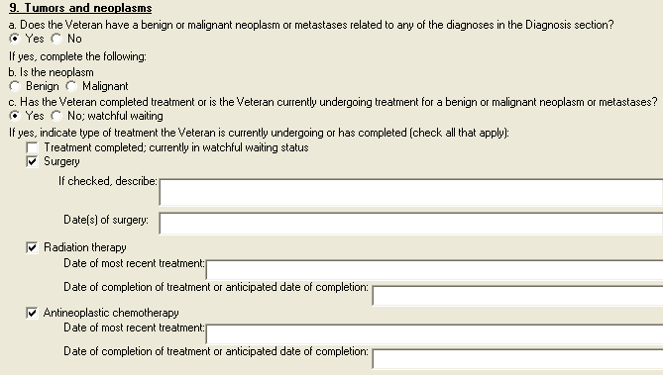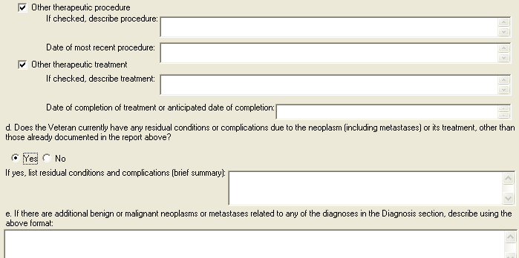

Figure 22: Print Example: DBQ – Male Reproductive System Conditions – 9. Tumors and Neoplasms
9. Tumors and neoplasms
-----------------------
a. Does the Veteran have a benign or malignant neoplasm or metastases
related to any of the diagnoses in the Diagnosis section?
[X] Yes [ ] No
If yes, complete the following:
b. Is the neoplasm
[ ] Benign [ ] Malignant
c. Has the Veteran completed treatment or is the Veteran currently
undergoing treatment for a benign or malignant neoplasm or metastases?
[X] Yes [ ] No; watchful waiting
If yes, indicate type of treatment the Veteran is currently undergoing
or has completed (check all that apply):
[ ] Treatment completed; currently in watchful waiting status
[X] Surgery
If checked, describe:
Date(s) of surgery:
[X] Radiation therapy
Date of most recent treatment:
Date of completion of treatment or anticipated date of
completion:
[X] Antineoplastic chemotherapy
Date of most recent treatment:
Date of completion of treatment or anticipated date of
completion:
[ ] Other therapeutic procedure
If checked, describe procedure:
Date of most recent procedure:
[ ] Other therapeutic treatment
If checked, describe treatment:
Date of completion of treatment or anticipated date of
completion:
d. Does the Veteran currently have any residual conditions or complications
due to the neoplasm (including metastases) or its treatment, other than those
already documented in the report above?
[ ] Yes [ ] No
If yes, list residual conditions and complications (brief summary):
e. If there are additional benign or malignant neoplasms or metastases
related to any of the diagnoses in the Diagnosis section, describe using the
above format:

Section 10. Other pertinent physical findings, complications, conditions, signs and/or symptoms
All questions in this section may be answered as described by the rules below. If all mandatory questions are not answered, the error message(s) will appear in a popup window as depicted below.

Table 11: Rules: DBQ – Male Reproductive System Conditions – 10. Other pertinent physical findings, complications, conditions, signs and/or symptoms
Field/Question | Field Disposition | Valid Values | Format | Error Message
10. Other pertinent physical findings, complications, conditions, signs and/or symptoms | Enabled, Read-Only | N/A | N/A | N/A
a. Does the Veteran have any scars (surgical or otherwise) related to any conditions or to the treatment of any conditions listed in the Diagnosis section above? | If Diagnosis = Yes and at least one diagnosis selected in the Diagnosis section; Enabled, Mandatory  Else; Enabled, Optional  Choose one valid value | [Yes; No] | N/A | Please indicate whether or not the Veteran has any scars (surgical or otherwise) related to any conditions (or their treatment) listed in the Diagnosis section.
If yes, are any of the scars painful and/or unstable, or is the total area of all related scars greater than 39 square cm (6 square inches)? | If previous question = Yes; Enabled, Mandatory, Choose one valid value  Else; Disabled | [Yes; No] | N/A | Please answer whether or not any of the scars are painful and/or unstable, or if the total area of all related scars is greater than 39 square cm (6 square inches).
If yes, also complete a Scars Questionnaire. | If previous question = Yes; Enabled, Read-Only  Else; Disabled | N/A | N/A | N/A
b. Does the Veteran have any other pertinent physical findings, complications, conditions, signs or symptoms? | If Diagnosis = Yes and at least one diagnosis selected in the Diagnosis section; Enabled, Mandatory  Else; Enabled, Optional  Choose one valid value | [Yes; No] | N/A | Please provide an answer to the question: Does the Veteran have any other pertinent physical findings, complications, conditions, signs or symptoms?
If yes, describe (brief summary): | If Does the Veteran have any other pertinent physical findings, complications, conditions, signs and/or symptoms? = Yes; Enabled, Mandatory  Else; Disabled | N/A | Free Text | Please describe any other pertinent physical findings, complications, conditions, signs or symptoms.

Figure 23: Template Example: DBQ – Male Reproductive System Conditions – 10. Other pertinent physical findings, complications, conditions, signs and/or symptoms
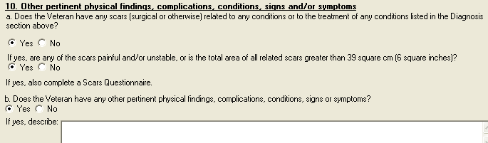

Figure 24: Print Example: DBQ – Male Reproductive System Conditions – 10. Other pertinent physical findings, complications, conditions, signs and/or symptoms
10. Other pertinent physical findings, complications, conditions, signs
and/or symptoms
----------------------------------------------------------------------
a. Does the Veteran have any scars (surgical or otherwise) related to any
conditions or to the treatment of any conditions listed in the Diagnosis
section above?
[ ] Yes [ ] No
If yes, are any of the scars painful and/or unstable, or is the
total area of all related scars greater than 39 square cm (6 square
inches)?
[ ] Yes [ ] No
If yes, also complete a Scars Questionnaire.
b. Does the Veteran have any other pertinent physical findings,
complications, conditions, signs or symptoms?
[ ] Yes [ ] No
If yes, describe:

Section 11. Diagnostic testing
All questions in this section may be answered as described by the rules below.
Table 12: Rules: DBQ – Male Reproductive System Conditions – 11. Diagnostic testing
Field/Question | Field Disposition | Valid Values | Format | Error Message
11. Diagnostic testing | Enabled; Read-Only | N/A | N/A | N/A
NOTE: If imaging studies, diagnostic procedures or laboratory testing has been performed and reflects the Veteran’s current condition, provide most recent results; no further studies or testing are required for this examination. | Enabled; Read-Only | N/A | N/A | N/A
a. Has the Veteran had a testicular biopsy to determine the presence of spermatozoa? | If Diagnosis = Yes and at least one diagnosis selected in the Diagnosis section; Enabled, Mandatory  Else; Enabled, Optional  Choose one valid value. | [Yes; No] | N/A | Please provide an answer to the question: Has the Veteran had a testicular biopsy to determine the presence of spermatozoa?
If yes, were spermatozoa present? | If Has the Veteran had a testicular biopsy to determine the presence of spermatozoa = Yes; Enabled, Mandatory, Choose one valid value.  Else; Disabled | [Yes; No] | N/A | Please answer whether or not spermatozoa were present in the testicular biopsy.
Date of biopsy: | If Has the Veteran had a testicular biopsy to determine the presence of spermatozoa = Yes; Enabled, Mandatory  Else; Disabled | N/A | Free Text | Please enter the date of the testicular biopsy.
b. Have any other imaging studies, diagnostic procedures or laboratory testing been performed and are the results available? | If Diagnosis = Yes and at least one diagnosis selected in the Diagnosis section; Enabled, Mandatory  Else; Enabled, Optional  Choose one valid value. | [Yes; No] | N/A | Please provide an answer to the question: Have any other imaging studies, diagnostic procedures or laboratory testing been performed and are the results available?
If yes, provide type of test or procedure, date and results (brief summary): | If Have any other imaging studies, diagnostic procedures or laboratory testing been performed and are the results available? = Yes; Enabled, Mandatory  Else; Disabled | N/A | Free Text | Please provide the type of test or procedure, its date and the results.

Figure 25: Template Example: DBQ – Male Reproductive System Conditions – 11. Diagnostic testing
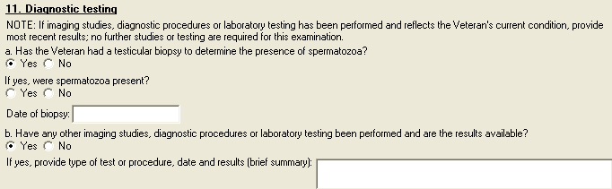

Figure 26: Print Example: DBQ – Male Reproductive System Conditions– 11. Diagnostic testing
11. Diagnostic testing
----------------------
NOTE: If imaging studies, diagnostic procedures or laboratory testing has
been performed and reflects the Veteran's current condition, provide most
recent results; no further studies or testing are required for this
examination.
a. Has the Veteran had a testicular biopsy to determine the presence of
spermatozoa?
[ ] Yes [ ] No
If yes, were spermatozoa present?
[ ] Yes [ ] No
Date of biopsy:
b. Have any other imaging studies, diagnostic procedures or laboratory
testing been performed and are the results available?
[ ] Yes [ ] No
If yes, provide type of test or procedure, date and results (brief
summary):

Section 12. Functional impact
All questions in this section may be answered as described by the rules below.

Table 13: Rules: DBQ – Male Reproductive System Conditions – 12. Functional impact
Field/Question | Field Disposition | Valid Values | Format | Error Message
12. Functional impact | Enabled; Read-Only | N/A | N/A | N/A
Does the Veteran’s male reproductive system condition(s), including neoplasms, if any, impact his ability to work? | If Diagnosis = Yes and at least one diagnosis selected in the Diagnosis section; Enabled, Mandatory  Else; Enabled, Optional  Choose one valid value | [Yes; No] | N/A | Please answer the question: Does the Veteran’s male reproductive system condition(s), including neoplasms, if any, impact his ability to work?
If yes, describe the impact of each of the Veteran’s male reproductive system condition(s), providing one or more examples: | If Does the Veteran’s male reproductive system condition(s), including neoplasms, if any, impact his ability to work? = Yes; Enabled, Mandatory  Else; Disabled | N/A | Free Text | Please describe the impact of each of the Veteran’s male reproductive system conditions on his ability to work, providing one or more examples.

Figure 27: Template Example: DBQ – Male Reproductive System Conditions – 12. Functional impact
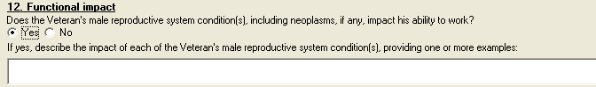

Figure 28: Print Example: DBQ – Male Reproductive System Conditions – 12. Functional impact
12. Functional impact
---------------------
Does the Veteran's male reproductive system condition(s), including
neoplasms, if any, impact his ability to work?
[ ] Yes [ ] No
If yes, describe the impact of each of the Veteran's male
reproductive system condition(s), providing one or more examples:

Section 13. Remarks, if any
All questions in this section may be answered as described by the rules below.

Table 14: Rules: DBQ – Male Reproductive System Conditions –13. Remarks, if any
Field/Question | Field Disposition | Valid Values | Format | Error Message
13. Remarks, if any: | Enabled, Optional | N/A | Free Text | N/A

Figure 29: Template Example: DBQ – Male Reproductive System Conditions – 13. Remarks, if any
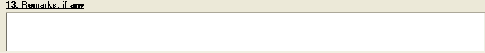

Figure 30: Print Example: DBQ – Male Reproductive System Conditions – 13. Remarks, if any
13. Remarks, if any:
--------------------

Male Reproductive System Conditions DBQ-AMIE Worksheet
The DBQ-AMIE worksheets are accessed via the Print Blank C&P Worksheet menu [DVBA C PRINT BLANK C&P WORKSHE] option. Select the “DBQ MALE REPRODUCTIVE SYSTEM CONDITIONS” worksheet. DBQ-AMIE worksheets should be sent to a printer.

Male Reproductive System Conditions
Disability Benefits Questionnaire

Name of patient/Veteran: _______________________ SSN: ________________

Your patient is applying to the U. S. Department of Veterans Affairs (VA) for
disability benefits. VA will consider the information you provide on this
questionnaire as part of their evaluation in processing the Veteran's claim.

1. Diagnosis:

Does the Veteran now have or has he ever been diagnosed with any conditions
of the male reproductive system?
___ Yes ___ No

If no, provide rationale (e.g., Veteran has never had any known male
reproductive organ conditions): _____________________________________________

If yes, indicate diagnoses: (check all that apply)
___ Erectile dysfunction ICD Code: ______ Date of Diagnosis: ____________
___ Penis, deformity (e.g., Peyronie's)
ICD Code: ______ Date of Diagnosis: ____________

___ Testis, atrophy, one or both
ICD Code: ______ Date of Diagnosis: ____________

___ Testis, removal, one or both
ICD Code: ______ Date of Diagnosis: ____________

___ Epididymitis, chronic ICD Code: ______ Date of Diagnosis: ____________
___ Epididymo-orchitis, chronic
ICD Code: ______ Date of Diagnosis: ____________

___ Prostate injury ICD Code: ______ Date of Diagnosis: ____________
___ Prostate hypertrophy (BPH)
ICD Code: ______ Date of Diagnosis: ____________

___ Prostatitis, chronic ICD Code: ______ Date of Diagnosis: ____________
___ Prostate surgical residuals (as addressed in items 3-6)
ICD Code: ______ Date of Diagnosis: ____________

___ Neoplasms of the male reproductive system
ICD Code: ______ Date of Diagnosis: ____________

___ Other male reproductive system condition (specify diagnosis, providing
only diagnoses that pertain to male reproductive system.)
ICD Code: ______ Date of Diagnosis: ____________

Other diagnosis #1: ____________________________
ICD code: ______________________________________
Date of diagnosis: _____________________________

Page: 2

Disability Benefits Questionnaire for
Male Reproductive System Conditions

Other diagnosis #2: ____________________________
ICD code: ______________________________________
Date of diagnosis: _____________________________

If there are additional diagnoses that pertain to the male reproductive organ
conditions, list using above format: ________________________________________

2. Medical history

a. Describe the history (including onset and course) of the Veteran's male
reproductive organ condition(s) (brief summary): ____________________________

b. Does the Veteran's treatment plan include taking continuous medication
for the diagnosed condition?
___ Yes ___ No List medications: ______________________________________

c. Has the Veteran had an orchiectomy?
___ Yes ___ No

Indicate testicle removed: ___ Right ___ Left ___ Both

Indicate reason for removal:
___ Undescended
___ Congenitally underdeveloped
___ Other: provide reason for removal: ___________________________________

3. Voiding dysfunction

Does the Veteran have a voiding dysfunction?
___ Yes ___ No

If yes, provide etiology of voiding dysfunction: ____________________________
If the Veteran has a voiding dysfunction, complete the following questions:

a. Does the voiding dysfunction cause urine leakage?
___ Yes ___ No

Indicate severity (check one):

___ Does not require the wearing of absorbent material
___ Requires absorbent material which must be changed less than 2 times
per day
___ Requires absorbent material which must be changed 2 to 4 times per day
___ Requires absorbent material which must be changed more than 4 times
per day
___ Other, describe: ______________________________________________________

Page: 3

Disability Benefits Questionnaire for
Male Reproductive System Conditions

b. Does the voiding dysfunction require the use of an appliance?
___ Yes ___ No

If yes, describe the appliance: _______________________________________

c. Does the voiding dysfunction cause increased urinary frequency?
___ Yes ___ No

If yes, check all that apply:
___ Daytime voiding interval between 2 and 3 hours
___ Daytime voiding interval between 1 and 2 hours
___ Daytime voiding interval less than 1 hour
___ Nighttime awakening to void 2 times
___ Nighttime awakening to void 3 to 4 times
___ Nighttime awakening to void 5 or more times

d. Does the voiding dysfunction cause signs or symptoms of obstructed
voiding?
___ Yes ___ No

If yes, check all that apply:
___ Hesitancy
If checked, is hesitancy marked?
___ Yes ___ No
___ Slow or weak stream
If checked, is stream markedly slow or weak?
___ Yes ___ No
___ Decreased force of stream
If checked, is force of stream markedly decreased?
___ Yes ___ No
___ Stricture disease requiring dilatation 1 to 2 times per year
___ Stricture disease requiring periodic dilatation every 2 to 3 months
___ Recurrent urinary tract infections secondary to obstruction
___ Uroflowmetry peak flow rate less than 10 cc/sec
___ Post void residuals greater than 150 cc
___ Urinary retention requiring intermittent catheterization
___ Urinary retention requiring continuous catheterization
___ Other, describe: _____________________________________________________

Page: 4

Disability Benefits Questionnaire for
Male Reproductive System Conditions

4. Urinary tract/kidney infection

Does the Veteran have a history of recurrent symptomatic urinary tract
or kidney infections?
___ Yes ___ No

If yes, provide etiology: ___________________________________________________

If the Veteran has had recurrent symptomatic urinary tract or kidney
infections, indicate all treatment modalities that apply:

___ No treatment
___ Long-term drug therapy
If checked, list medications used and indicate dates for courses of
treatment over the past 12 months: ___________________________________
___ Hospitalization
If checked, indicate frequency of hospitalization:
___ 1 or 2 per year
___ > 2 per year
___ Drainage
If checked, indicate dates when drainage performed over past 12
months: ______________________
___ Continuous intensive management
If checked, indicate types of treatment and medications used over past
12 months: ___________________
___ Intermittent intensive management
If checked, indicate types of treatment and medications used over past
12 months: ___________________
___ Other, describe: _____________________________________________________

5. Erectile dysfunction

a. Does the Veteran have erectile dysfunction?
___ Yes ___ No

If yes, provide etiology:____________________________________________________

b. If the Veteran has erectile dysfunction, is it as likely as not (at least
a 50% probability) attributable to one of the diagnoses in Section 1,
including residuals of treatment for this diagnosis?
___ Yes ___ No

If yes, specify the diagnosis to which the erectile dysfunction is as likely
as not attributable: ________________________________________________________

Page: 5

Disability Benefits Questionnaire for
Male Reproductive System Conditions

c. If the Veteran has erectile dysfunction, is he able to achieve an erection
sufficient for penetration and ejaculation (without medication)?
___ Yes ___ No

If no, is the Veteran able to achieve an erection sufficient for penetration
and ejaculation (with medication)?
___ Yes ___ No

6. Retrograde ejaculation

a. Does the Veteran have retrograde ejaculation?
___ Yes ___ No

If yes, provide etiology of the retrograde ejaculation:______________________

b. If the Veteran has retrograde ejaculation, is it as likely as not (at
least a 50% probability) attributable to one of the diagnoses in Section 1,
including residuals of treatment for this diagnosis?
___ Yes ___ No

If yes, specify the diagnosis to which the retrograde ejaculation is as
likely as not attributable: _________________________________________________

7. Male reproductive organ infections

Does the Veteran have a history of chronic epididymitis, epididymo-orchitis
or prostatitis?
___ Yes ___ No

If yes, indicate all treatment modalities that apply:
___ No treatment
___ Long-term drug therapy
If checked, list medications used and indicate dates for courses of
treatment over the past 12 months: ___________________________________
___ Hospitalization
If checked, indicate frequency of hospitalization:
___ 1 or 2 per year
___ > 2 per year
___ Continuous intensive management
If checked, indicate types of treatment and medications used over
past 12 months: ______________________________________________________
___ Intermittent intensive management
If checked, indicate types of treatment and medications used over
past 12 months: ______________________________________________________
___ Other, describe: _____________________________________________________

Page: 6

Disability Benefits Questionnaire for
Male Reproductive System Conditions

8. Physical exam

a. Penis
___ Normal
___ Not examined per Veteran's request
___ Not examined; penis exam not relevant to condition
___ Abnormal
If abnormal, indicate severity:
___ Loss/removal of half or more of penis
___ Loss/removal of glans penis
___ Penis deformity(such as Peyronie's disease)
If checked, describe: _________________________

b. Testes
___ Normal
___ Not examined per Veteran's request
___ Not examined; testicular exam not relevant to condition
___ Abnormal

If abnormal, check all that apply:
Right testicle
___ Size 1/3 or less of normal
___ Size 1/2 to 1/3 of normal
___ Considerably harder than normal
___ Considerably softer than normal
___ Absent
___ Other abnormality,
Describe: _____________________________________

Left testicle
___ Size 1/3 or less of normal
___ Size 1/2 to 1/3 of normal
___ Considerably harder than normal
___ Considerably softer than normal
___ Absent
___ Other abnormality,
Describe: _____________________________________

Page: 7

Disability Benefits Questionnaire for
Male Reproductive System Conditions

c. Epididymis
___ Normal
___ Not examined per Veteran's request
___ Not examined; epididymis exam not relevant to condition
___ Abnormal

If abnormal, check all that apply:
Right epididymis
___ Tender to palpation
___ Other, describe: ______________________________

Left epididymis
___ Tender to palpation
___ Other, describe: ______________________________

d. Prostate
___ Normal
___ Not examined per Veteran's request
___ Not examined; prostate exam not relevant to condition
___ Abnormal
If abnormal, describe: ___________________________

9. Tumors and neoplasms

a. Does the Veteran have a benign or malignant neoplasm or metastases
related to any of the diagnoses in the Diagnosis section?
___ Yes ___ No

If yes, complete the following:

b. Is the neoplasm
___ Benign ___ Malignant

Page: 8

Disability Benefits Questionnaire for
Male Reproductive System Conditions

c. Has the Veteran completed treatment or is the Veteran currently undergoing
treatment for a benign or malignant neoplasm or metastases?
___ Yes ___ No; watchful waiting

If yes, indicate type of treatment the Veteran is currently undergoing or
has completed (check all that apply):
___ Treatment completed; currently in watchful waiting status
___ Surgery
If checked, describe: _____________________________________________
Date(s) of surgery: ______________________________
___ Radiation therapy
Date of most recent treatment: _____________________
Date of completion of treatment or anticipated date of completion:
____________________
___ Antineoplastic chemotherapy
Date of most recent treatment: _____________________
Date of completion of treatment or anticipated date of completion:
_____________________
___ Other therapeutic procedure
If checked, describe procedure: ___________________________________
Date of most recent procedure: ____________________
___ Other therapeutic treatment
If checked, describe treatment: ___________________________________
Date of completion of treatment or anticipated date of completion:
_____________________

d. Does the Veteran currently have any residual conditions or complications
due to the neoplasm (including metastases) or its treatment, other than those
already documented in the report above?
___ Yes ___ No

If yes, list residual conditions and complications (brief summary):
_____________________________________________________________________________

e. If there are additional benign or malignant neoplasms or metastases
related to any of the diagnoses in the Diagnosis section, describe using the
above format: _______________________________________________________________

Page: 9

Disability Benefits Questionnaire for
Male Reproductive System Conditions

10. Other pertinent physical findings, complications, conditions, signs
and/or symptoms

a. Does the Veteran have any scars (surgical or otherwise) related to any
conditions or to the treatment of any conditions listed in the Diagnosis
section above?
___ Yes ___ No

If yes, are any of the scars painful and/or unstable, or is the total area
of all related scars greater than 39 square cm (6 square inches)?
___ Yes ___ No
If yes, also complete a Scars Questionnaire.

b. Does the Veteran have any other pertinent physical findings,
complications, conditions, signs or symptoms?
___ Yes ___ No

If yes, describe (brief summary): ___________________________________________

11. Diagnostic testing

NOTE: If imaging studies, diagnostic procedures or laboratory testing has
been performed and reflects the Veteran's current condition, provide most
recent results; no further studies or testing are required for this
examination.

a. Has the Veteran had a testicular biopsy to determine the presence of
spermatozoa?
___ Yes ___ No
If yes, were spermatozoa present?
___ Yes ___ No
Date of biopsy: ________________

b. Have any other imaging studies, diagnostic procedures or laboratory
testing been performed and are the results available?
___ Yes ___ No

If yes, provide type of test or procedure, date and results (brief summary):
_____________________________________________________________________________

12. Functional impact

Does the Veteran's male reproductive system condition(s), including neoplasms,
if any, impact his ability to work?
___ Yes ___ No

If yes, describe the impact of each of the Veteran's male reproductive system
condition(s), providing one or more examples: _______________________________

Page: 10

Disability Benefits Questionnaire for
Male Reproductive System Conditions

13. Remarks, if any: ________________________________________________________

Physician signature: _____________________________________ Date: ____________

Physician printed name: __________________________________ Phone: ___________

Medical license #: _______________________________________ Fax: _____________

Physician address: __________________________________________________________

NOTE: VA may request additional medical information, including additional
examinations if necessary to complete VA's review of the Veteran's
application.

